**Air Cargo Analysis...**

Description

Air Cargo is an aviation company that provides air transportation services for passengers and freight. Air Cargo uses its aircraft to provide different services with the help of partnerships or alliances with other airlines. The company wants to prepare reports on regular passengers, busiest routes, ticket sales details, and other scenarios to improve the ease of travel and booking for customers.

**Project Objective:**

You, as a DBA expert, need to focus on identifying the regular customers to provide offers, analyze the busiest route which helps to increase the number of aircraft required and prepare an analysis to determine the ticket sales details. This will ensure that the company improves its operability and becomes more customer-centric and a favorable choice for air travel.

**Note:** You must download the dataset from the course resource section in the LMS and create the tables to perform the above objective.

**Dataset description:**

**Customer:**Contains the information of customers

* customer_id – ID of the customer
* first_name – First name of the customer
* last_name – Last name of the customer
* date_of_birth – Date of birth of the customer
* gender – Gender of the customer

**passengers_on_flights:**Contains information about the travel details

* aircraft_id – ID of each aircraft in a brand
* route_id – Route ID of from and to location
* customer_id – ID of the customer
* depart – Departure place from the airport
* arrival – Arrival place in the airport
* seat_num – Unique seat number for each passenger
* class_id – ID of travel class
* travel_date – Travel date of each passenger
* flight_num – Specific flight number for each route

**ticket_details:**Contains information about the ticket details

* p_date – Ticket purchase date
* customer_id – ID of the customer
* aircraft_id – ID of each aircraft in a brand
* class_id – ID of travel class
* no_of_tickets – Number of tickets purchased
* a_code – Code of each airport
* price_per_ticket – Price of a ticket
* brand – Aviation service provider for each aircraft

**routes:** Contains information about the route details

* Route_id – Route ID of from and to location
* Flight_num – Specific fight number for each route
* Origin_airport – Departure location
* Destination_airport – Arrival location
* Aircraft_id – ID of each aircraft in a brand
* Distance_miles – Distance between departure and arrival location

**Following operations should be performed:**

1. Write a query to create route_details table using suitable data types for the fields, such as route_id, flight_num, origin_airport, destination_airport, aircraft_id, and distance_miles. Implement the check constraint for the flight number and unique constraint for the route_id fields. Also, make sure that the distance miles field is greater than 0.

***create table route_details***

***( route_id int not null,***

***flight_num int not null,***

***origin_airport varchar(50) not null,***

***destination_airport varchar(50) not null,***

***aircraft_id varchar(50) not null,***

***distance_miles int not null,***

***primary key (route_id),***

***constraint flight_num_check check ((substr(flight_num,1,2)=11)),***

***constraint route_id_check check (distance_miles>0) )***

***select * from route_details***

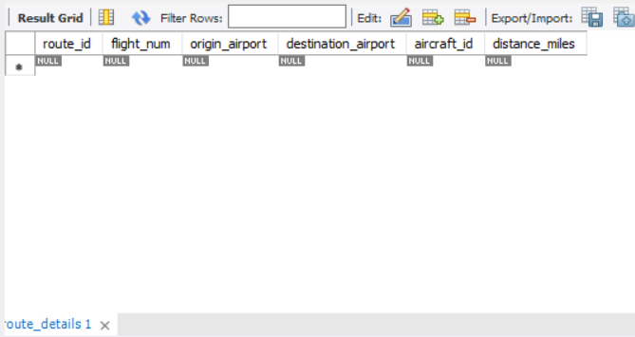

1. Write a query to display all the passengers (customers) who have travelled in routes 01 to 25. Take data  from the passengers_on_flights table.

***select * from passengers_on_flights***

***where route_id between 1 and 25***

***order by route_id ;***

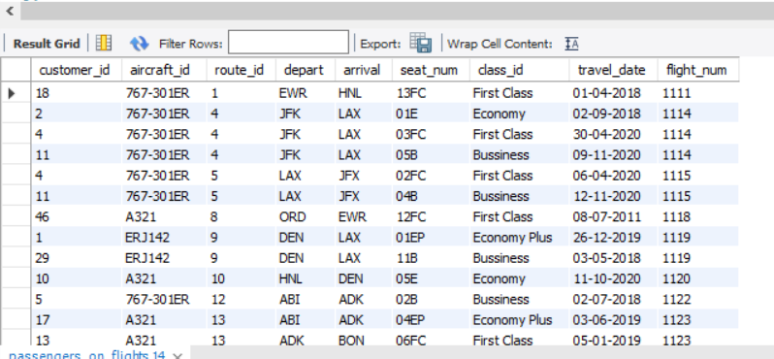

1. Write a query to identify the number of passengers and total revenue in business class from the ticket_details table.

***select count(customer_id) as num_of_passenger, sum(Price_per_ticket) as total_revenue, class_id***

***from ticket_details***

***where class_id="Bussiness"***

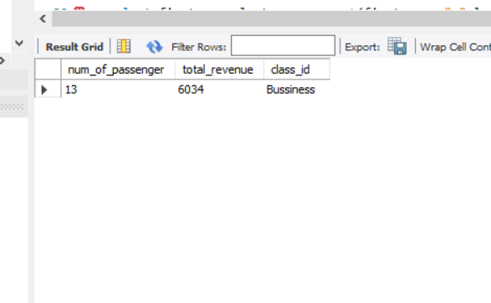

1. Write a query to display the full name of the customer by extracting the first name and last name from the customer table.

***select first_name,last_name,concat(first_name," ",last_name) as full_name from customer***

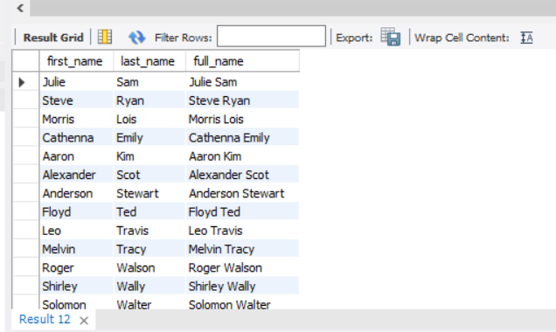

1. Write a query to extract the customers who have registered and booked a ticket. Use data from the customer and ticket_details tables.

***SELECT***

***customer.customer_id,***

***CONCAT(first_name, " ", last_name) AS full_name,***

***COUNT(ticket_details.no_of_tickets) AS total_booked_ticket***

***FROM***

***customer***

***JOIN***

***ticket_details USING (customer_id)***

***GROUP BY***

***customer.customer_id, full_name***

***ORDER BY***

***total_booked_ticket DESC;***

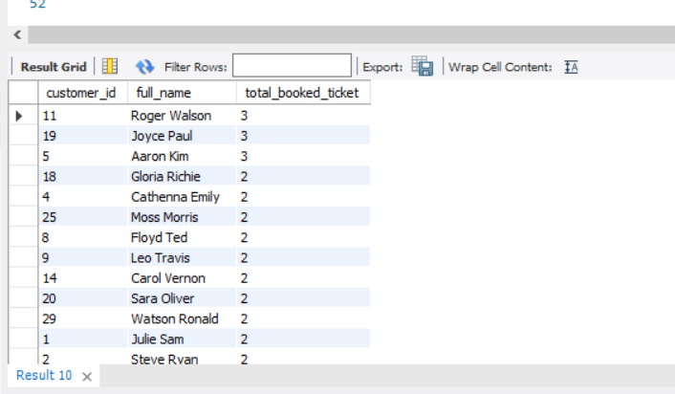

1. Write a query to identify the customer’s first name and last name based on their customer ID and brand (Emirates) from the ticket_details table.

***select customer.customer_id,first_name,last_name,ticket_details.brand***

***from customer***

***join ticket_details on customer.customer_id=ticket_details.customer_id***

***where brand="Emirates"***

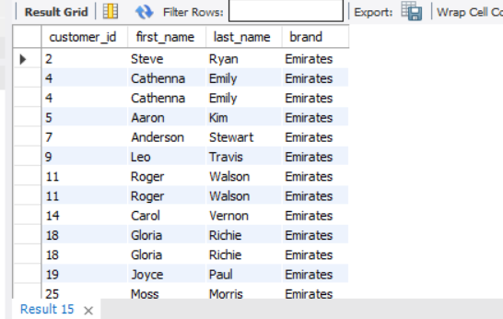

1. Write a query to identify the customers who have travelled by *Economy Plus* class using Group By and Having clause on the passengers_on_flights table.

***SELECT***

***customer.customer_id,***

***CONCAT(customer.first_name, " ", customer.last_name) AS name,***

***ticket_details.class_id***

***FROM***

***customer***

***JOIN***

***ticket_details***

***ON***

***ticket_details.customer_id = customer.customer_id***

***WHERE***

***ticket_details.class_id = 'Economy Plus'***

***GROUP BY***

***customer.customer_id, name, ticket_details.class_id;***

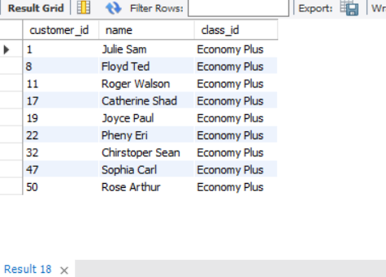

1. Write a query to identify whether the revenue has crossed 10000 using the IF clause on the ticket_details table.

***select if( sum(no_of_tickets*Price_per_ticket) > 10000 ,"revenue > 10000","revenue < 10000") as revenue_status***

***from ticket_details***

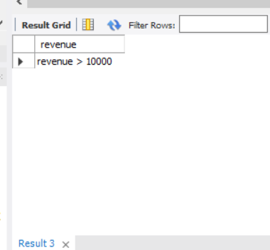

1. Write a query to create and grant access to a new user to perform operations on a database.

***create user 'ad'@'localhost' identified by 'password';***

***grant all privileges on *.* to 'ad'@'localhost' with grant option;***

1. Write a query to find the maximum ticket price for each class using window functions on the ticket_details table.

***SELECT***

***class_id,***

***MAX(Price_per_ticket) AS max_price***

***FROM***

***ticket_details***

***GROUP BY class_id***

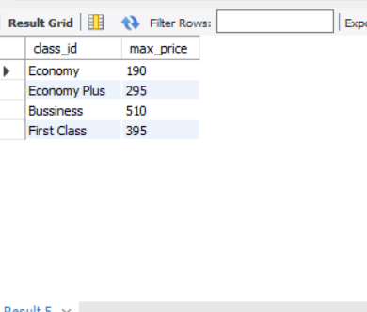

1. Write a query to extract the passengers whose route ID is 4 by improving the speed and performance of the passengers_on_flights table.

***select * from passengers_on_flights***

***where route_id='4'***

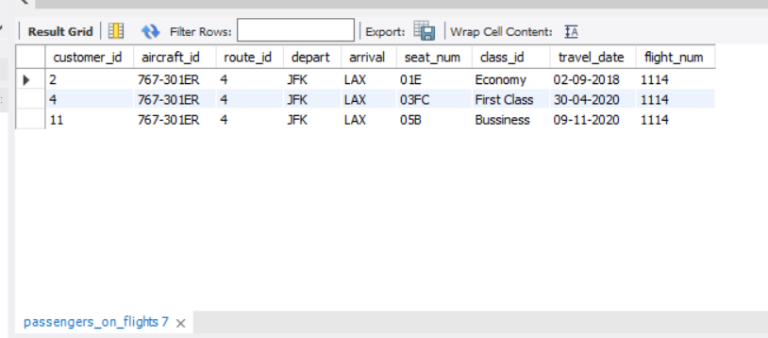

1. For the route ID 4, write a query to view the execution plan of the passengers_on_flights table.

***CREATE VIEW passengers_with_route_4 AS***

***SELECT \****

***FROM passengers_on_flights***

***WHERE route_id = 4***

1. Write a query to calculate the total price of all tickets booked by a customer across different aircraft IDs using rollup function.

***SELECT***

***customer_id,***

***aircraft_id,***

***SUM( Price_per_ticket*no_of_tickets ) AS total_price***

***FROM***

***ticket_details***

***GROUP BY***

***ROLLUP(customer_id, aircraft_id);***

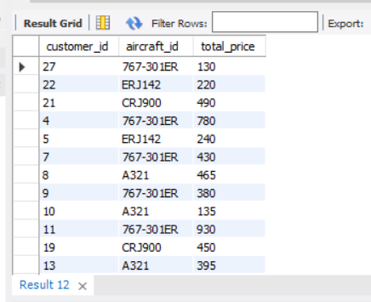

1. Write a query to create a view with only business class customers along with the brand of airlines.

***CREATE VIEW passengers_with_classid_business AS***

***SELECT \****

***FROM ticket_details***

***WHERE class_id = 'Bussiness'***

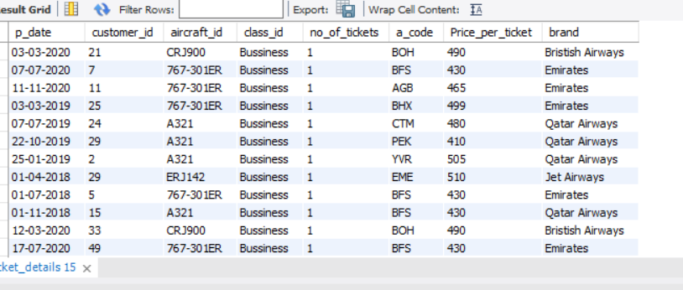

1. Write a query to create a stored procedure to get the details of all passengers flying between a range of routes defined in run time. Also, return an error message if the table doesn't exist.

***DELIMITER //***

***CREATE PROCEDURE PASSENGERS_BY_ROUTES(IN min_route INT, IN max_route INT)***

***BEGIN***

***SELECT * FROM passengers_on_flights***

***WHERE route_id BETWEEN min_route AND max_route;***

***END //***

***DELIMITER ;***

1. Write a query to create a stored procedure that extracts all the details from the routes table where the travelled distance is more than 2000 miles.

***DELIMITER //***

***CREATE PROCEDURE DISTANCE_BY_ROUTES()***

***BEGIN***

***SELECT * FROM routes***

***WHERE distance_miles > 2000 ;***

***END //***

***DELIMITER ;***

1. Write a query to create a stored procedure that groups the distance travelled by each flight into three categories. The categories are, short distance travel (SDT) for >=0 AND <= 2000 miles, intermediate distance travel (IDT) for >2000 AND <=6500, and long-distance travel (LDT) for >6500.

DELIMITER //

***CREATE PROCEDURE DISTANCE_CATEGORIES()***

***BEGIN***

***SELECT***

***flight_num,***

***route_id,***

***distance_miles,***

***CASE***

***WHEN distance_miles >= 0 AND distance_miles <= 2000 THEN 'SDT'***

***WHEN distance_miles > 2000 AND distance_miles <= 6500 THEN 'IDT'***

***ELSE 'LDT'***

***END AS travel_category***

***FROM***

***routes;***

***END //***

***DELIMITER ;***

1. Write a query to extract ticket purchase date, customer ID, class ID and specify if the complimentary services are provided for the specific class using a stored function in stored procedure on the ticket_details table.

**Condition:**

* If the class is *Business* and *Economy Plus,* then complimentary services are given as *Yes,*else it is *No*

***DELIMITER //***

***CREATE FUNCTION complimentary_services(class_id VARCHAR(50))***

***RETURNS VARCHAR(3)***

***DETERMINISTIC***

***BEGIN***

***DECLARE complimentary_services VARCHAR(3);***

***IF class_id IN ('Business', 'Economy Plus') THEN***

***SET complimentary_services = 'Yes';***

***ELSE***

***SET complimentary_services = 'No';***

***END IF;***

***RETURN complimentary_services;***

***END //***

***DELIMITER ;***

1. Write a query to extract the first record of the customer whose last name ends with Scott using a cursor from the customer table.

DELIMITER //

***CREATE PROCEDURE GetFirstCustomerWithLastNameScott()***

***BEGIN***

***DECLARE done INT DEFAULT FALSE;***

***DECLARE first_name VARCHAR(50);***

***DECLARE last_name VARCHAR(50);***

***DECLARE customer_id INT;***

***DECLARE cur CURSOR FOR***

***SELECT customer_id, first_name, last_name***

***FROM customer***

***WHERE last_name LIKE '%Scott';***

***DECLARE CONTINUE HANDLER FOR NOT FOUND SET done = TRUE;***

***OPEN cur;***

***FETCH cur INTO customer_id, first_name, last_name;***

***IF NOT done THEN***

***SELECT customer_id, first_name, last_name;***

***END IF;***

***CLOSE cur;***

***END //***

***DELIMITER ;***